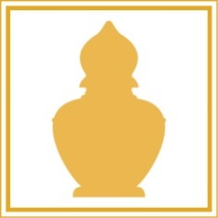

Ms Emma Boarsma

Primavera

Le Grandes Vaux

Jersey

Channel Islands

JE2 7NA

01/09/2017

We are in the process of updating our database for the newly formed Maharishi AyurVeda Health Centre in Rendlesham.

This is an exciting new project with its premises next to the newly opened Maharishi Peace Palace.

As part of our ongoing communications with our contacts we plan to send out a regular monthly newsletter.

This will have news of forthcoming treatment sessions, special promotions, and seasonal tips to help maintain good health. We will have regular articles written by Sue Lincoln our own resident and highly qualified Maharishi AyurVeda health practitioner.

It would be our pleasure to include you in this monthly mailing by email.

To date we do not have your email address on our system.

If you would like to be included in this regular mailing please simply forward your email address and full name to [enquiries@ayurveda-rendlesham.co.uk](mailto:enquiries@ayurveda-rendlesham.co.uk). For further information please visit our website www.ayurveda-rendlesham.co.uk.

We look forward hearing from you.

Wishing you the very best of health…

*Maharishi AyurVeda Health Centre team*

MAHARISHI AYURVEDA HEALTH CENTRE

RENDLESHAM

Company number 02763873 • VAT registration number 218 7793 69

Maharishi AyurVeda Health Centre Rendlesham Ltd

3 Peace Palace Gardens, Rendlesham, Woodbridge IP12 2HG

T: 01394 548764 • E: enquiries@ayurveda-rendlesham.co.uk • W: www.ayurveda-rendlesham.co.uk